7 klasė
Pamokos Nr.5 “Kartojame intervalus”
UŽDUOTYS
Mokinio vardas, pavardė....................................................
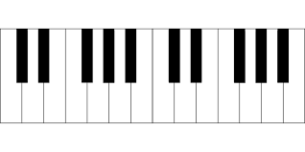
1. Sudarykite intervalus aukštyn: 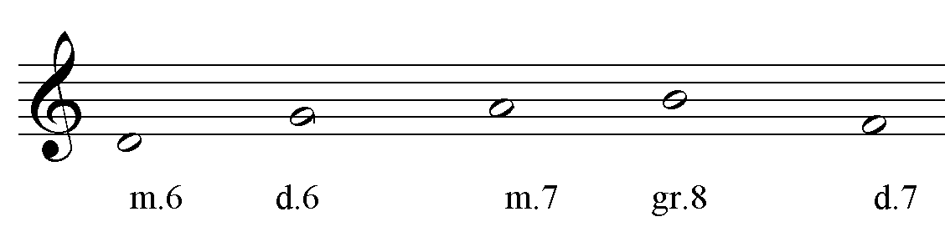
2. Sudarykite intervalus žemyn:
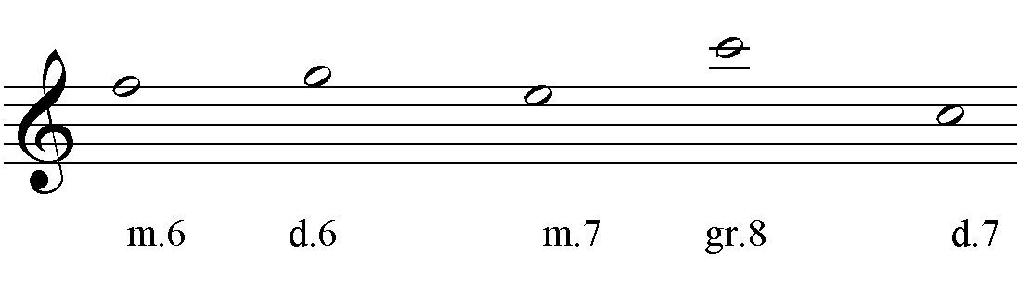
3. Nustatykite ir pažymėkite, kokie tai intervalai:
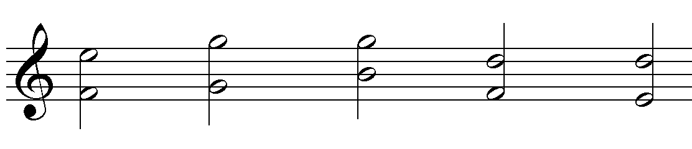
4. Parašykite ritmo diktantą Nr.3 (žr. užduotys „Diktantai-3“):

5. Parašykite melodinį diktantą Nr.3 (žr. užduotys „Diktantai-3“):
________________________________________________________________________________________________________________________________________________________________________________________________________________________________________________________________________________________________________________________________________________________________________________________________________________________________________________________________________________________________________________________________________________________________________________________________________________________________________________________________________________________________________________________________________________________________________________________________________________________________________________________________________________________________________________________________________________________________________________________________________________________________________________

_________________________________________________________________________________________________________________________________________________________________________________________________________________________________________________________________________________________________________________________________________________________________________________________________________________________________________________________________________________________________________________________________________________________________________________________________________________________________________________________________________________________________________________________________________________________________________________________________________________________________________________________________________________________________________________________________________________________________________________________________________________________________________________

