V klasė: 6-tos pamokos užduotys raštu.
Darbą atliko mokinys(ė):_______________________________
- Pamatykim: kokia variacijų temos tonacija?.........................
Kokia tempo Sostenuto reikšmė?..........................
Koks šios melodijos metras?.............................. 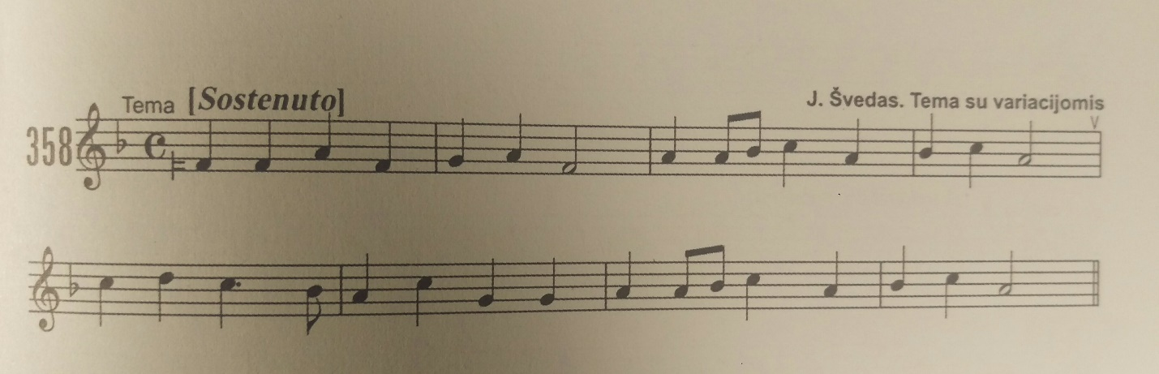
- Kas pakeista/varijuota I varijacijoje?..........................(ritmas,tonacija, metras)
Surask ir pažymėk ženklu ,, >“ po nata išlikusias Temos natas pirmuose 4-riuose taktuose: 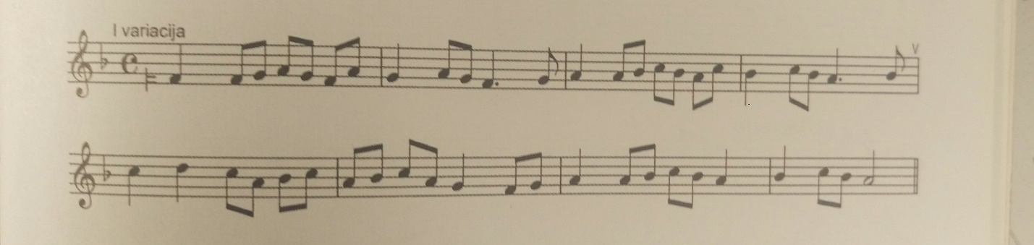
- Nustatyk II varijacijos tonaciją........................ Čia kompozitorius varijuoja ir ritmą, ir tonaciją. 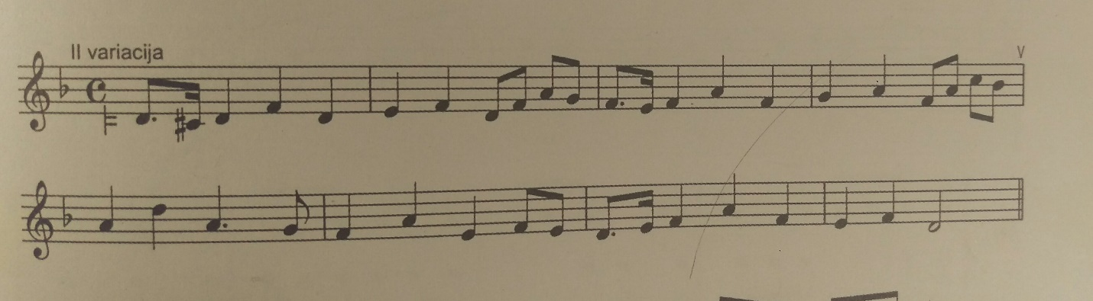
V klasė 6 pamoka (tesinys)
- Kas pakeista/varijuota III varijacijoje?.............................
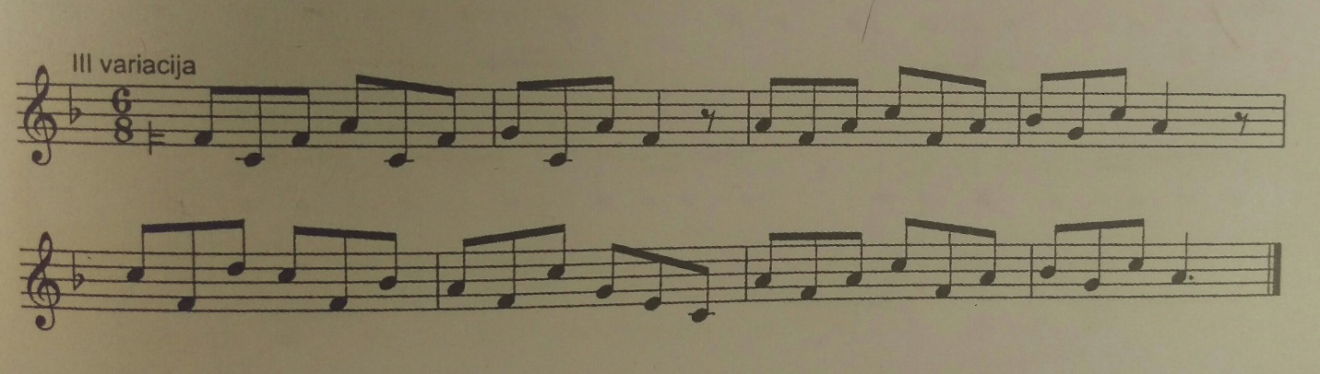

- Diktantai:
NR. 1
____________________________________________________________________________________________________________________________________________________________________________________________________________________________________________________________________________________________________________________________________________________________________________________________________________________________________________________________________________________________________________________________________________________________

NR. 2
----------------------------------------------------------------------------------------------------------------------------------------------------------------------------------------------------------------------------------------------------------------------------------------------------------------------------------------------------------------------------------------------------------------------------------------------------------------------------------------------------------------------------------------------------------------------------------------------------------------------------------------------------------------------------------------------------------------------------------------------------------------------------------------------------------------------------------------------------------------------------------------------------------------

_________________________________________________________________________________________________________________________________________________________________________________________________________________________________________________________________________________________________________________________________________________________________________________________________________________________________________________________________________________________________________________________________________________________________________________________________________

