V klasė: 7-tos pamokos užduotys raštu.
Darbą atliko mokinys(ė):_______________________________
- Parašyk gamoje As-dur laipsnių seką – I / V \ V / III \ VII / II - I (rodyklė/ aukštyn arba \ žemyn, pradėk nuo T pirmoje oktavoje). Parašyk kokie 6 intervalai yra tarp užrašytų laipsnių? :
_________________________________________________________________________________________________________________________________________________________________________________________________________________________________________________________________________________________________________________________________________________________________________________________________________________________________________________________________________________________________________________________________________________________________________________________________________

- Parašyk gamoje As-dur akordų seką ( kadenciją) T S6 D D7 T:
____________________________________________________________________________________________________________________________________________________________________________________________________________________________________________________________________________________________________________________________________________________________________________________________________________________________________________________________________________________________________________________________________________________________

- As- dur tonacijoje Franco Šuberto Lopšinė yra su akompanimentu-harmoniniu pritarimu.
Parašyk po natomis kokius akordus randi ( T, S ,D ,D7...)?
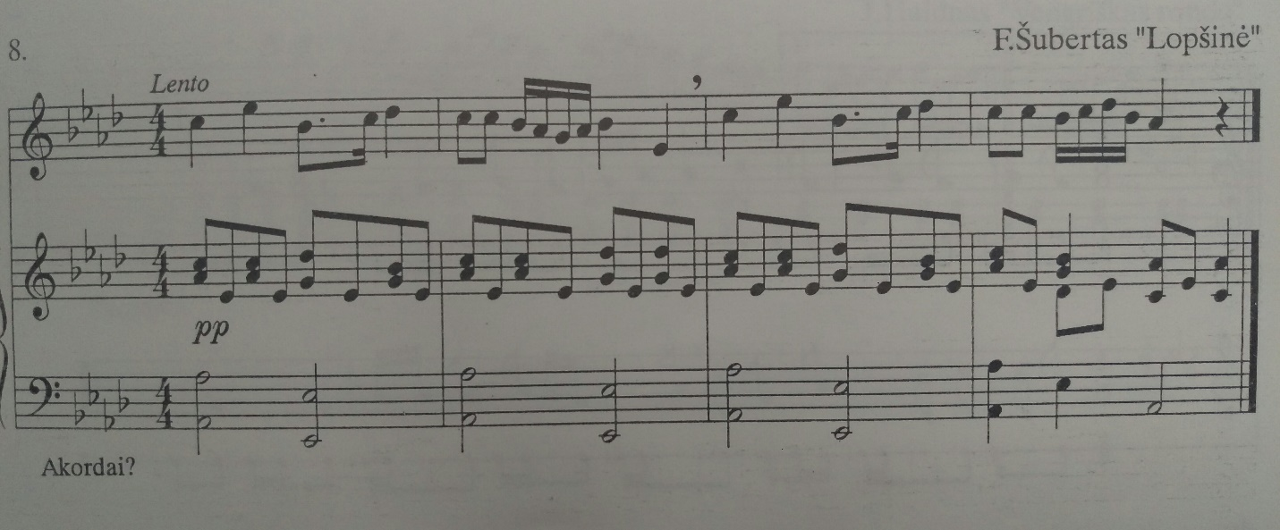
- Diktantai:

Nr. 1________________________________________________________________________________________________________

Nr. 2
____________________________________________________________________________________________________________________________________________________________________________________________________________________________________________________________________________________________________________________________________________________________________________________________________________________________________________________________________________________________________________________________________________________________

