V klasė: 8-tos pamokos užduotys raštu.
Darbą atliko mokinys(ė):_______________________________
- a) Žano Batisto Liuli melodijoja yra fis-moll tonacijoje. Kokia šiame pavyzdyje minoro rūšis?______________________
b) Surask ir parašyk kurie intervalai paskutiniuose trijuose taktuose (g1,, m2, d2, g4, p4, m6, m7) ta tvarka, kaip jie atsiranda melodijoje_____________________________________________________________________

c) Kokios natos sudaro tritonio intervalą?______________________________________

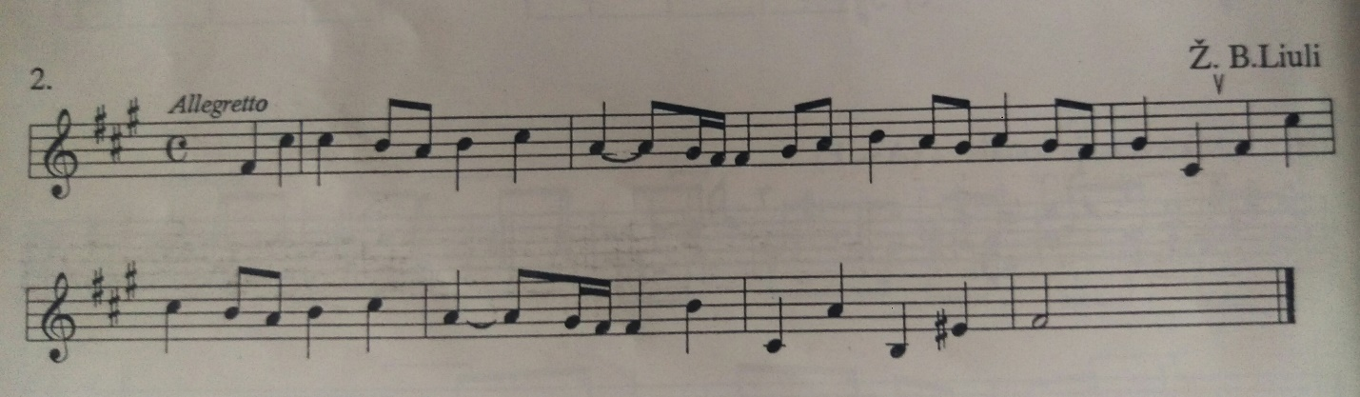

- Tonacijoje a-moll užrašyk 5-kis harmoninius ( du garsai skamba kartu) intervalus iš duotų laipsnių į penklinę. Tada parašyk kokie tai intervalai į nurodytus langelius:

____________________________________________________________________________________________________________________________________________________________________________________________________________________________________________________________________________________________________________________________________________________________________________________________________________________________________________________________________________________________________________________________________________________________

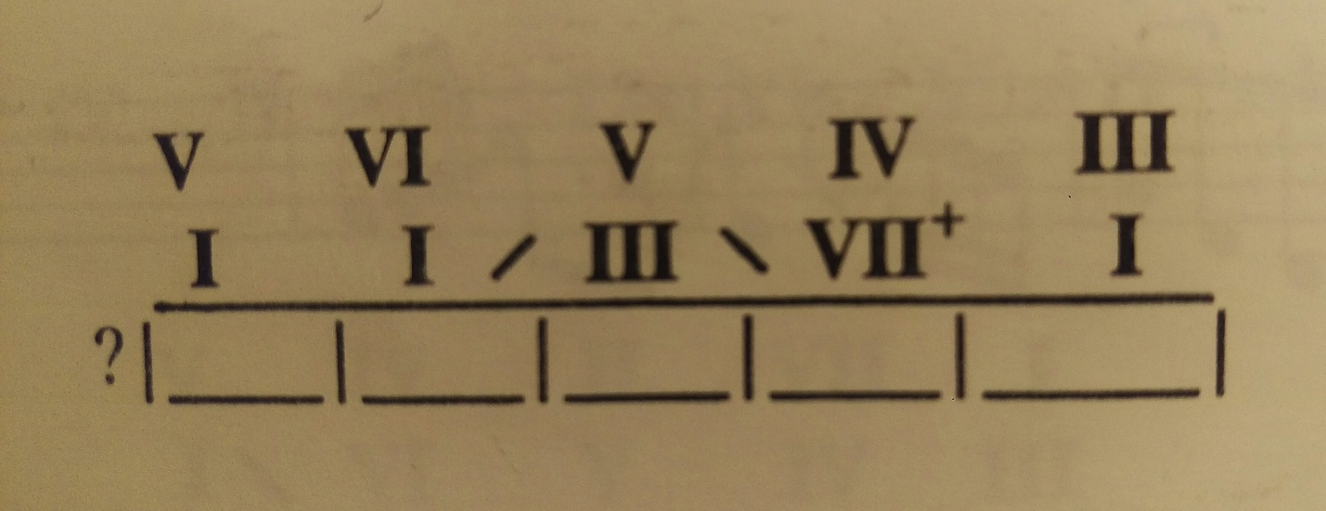

- Diktantai Nr. 5.
Ritminis:
________________________________________________________________________________________________________________________________________________________________________________________________________________________________________________________________________________________________________________________________________________________________________________________________________________________________________________________________________________________________________________________________________________________________________________
Melodinis:
________________________________________________________________________________________________________________________________________________________________________________________________________________________________________________________________________________________________________________________________________________________________________________________________________________________________________________________________________________________________________________________________________________________________________________

________________________________________________________________________________________________________________________________________________________________________________________________________________________________________________________________________________________________________________________________________________________________________________________________________________________________________________________________________________________________________________________________________________________________________________

